Existing Conditions Lawrence Street (7/18/2025)
Poor/no connectivity to road crossings/cross walk #1
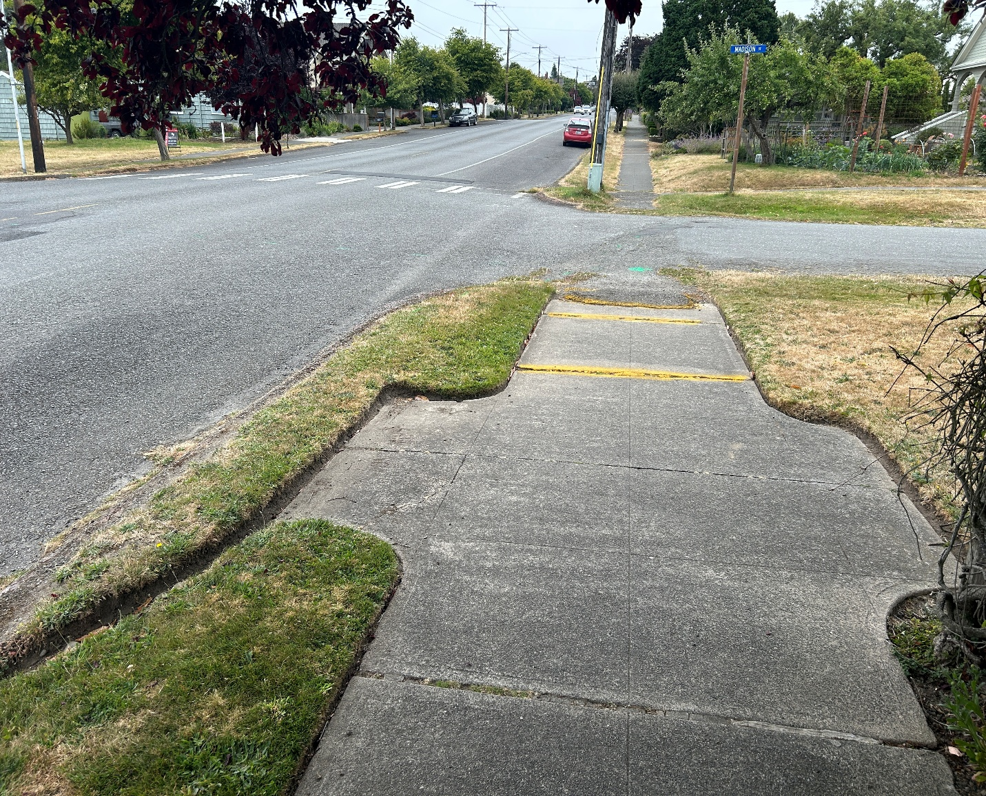

Poor/no connectivity to road crossings/cross walk #2
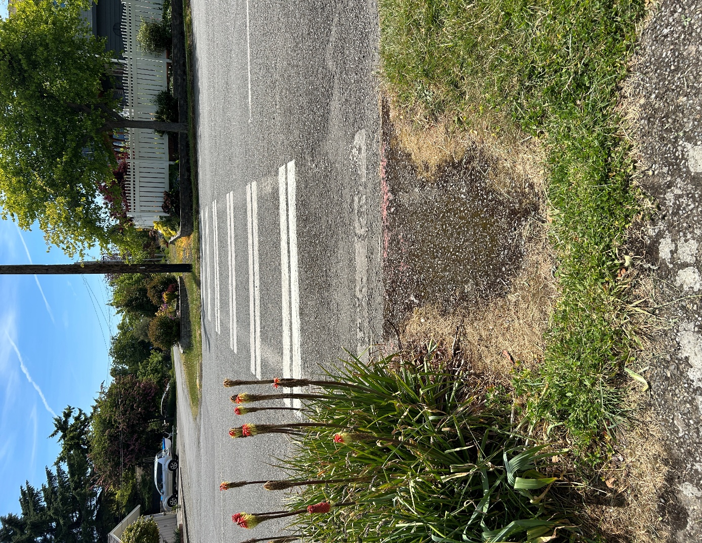

Poor/no connectivity to road crossings/cross walk #3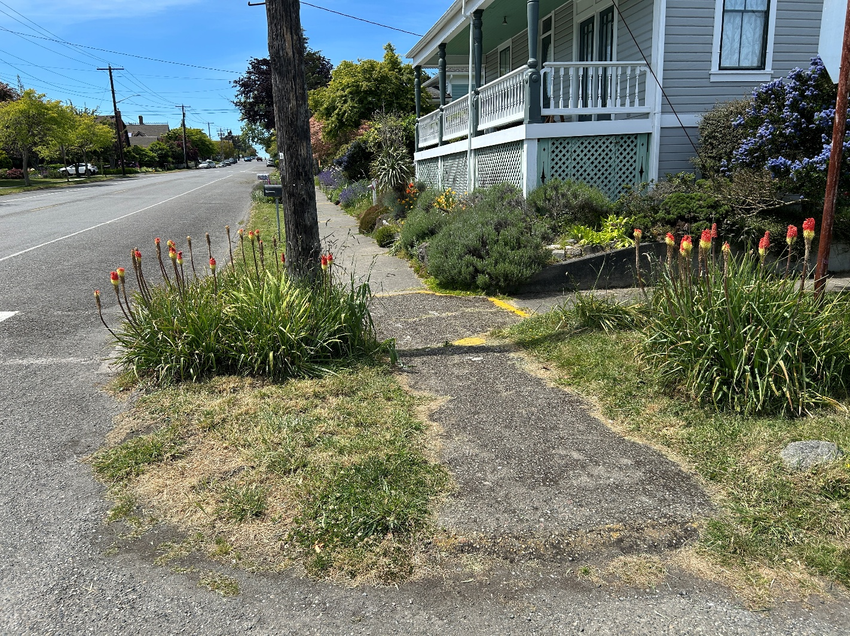

Poor/no connectivity to road crossings/cross walk #4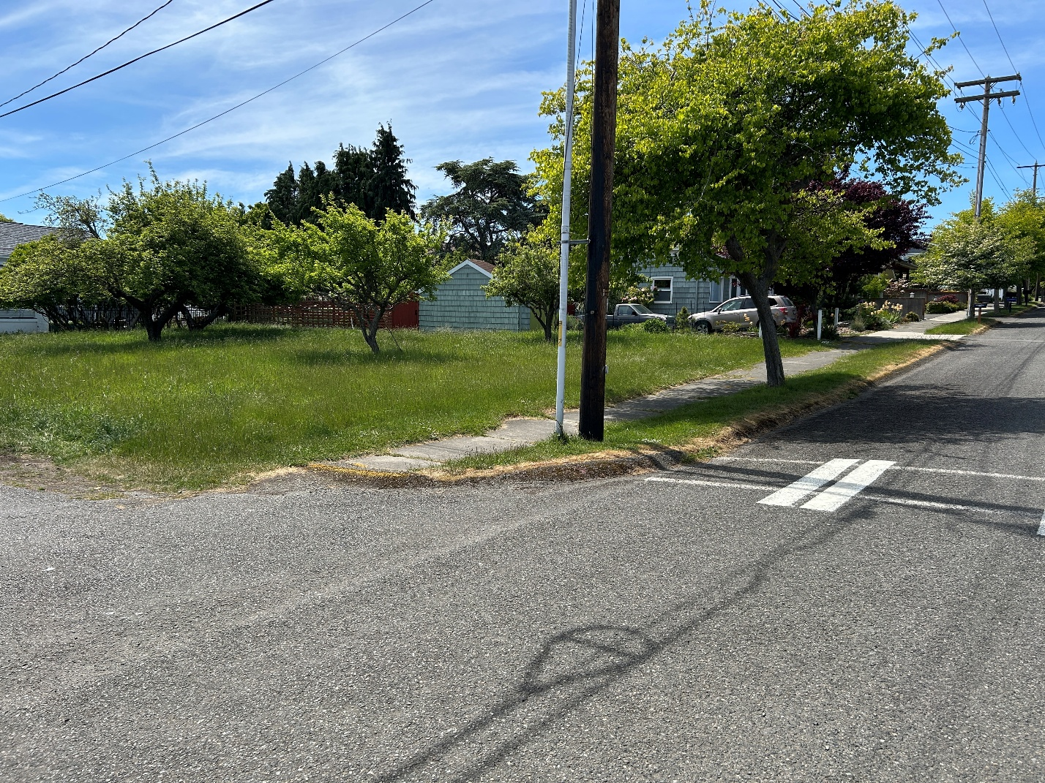
Poor/no connectivity to road crossings/cross walk #5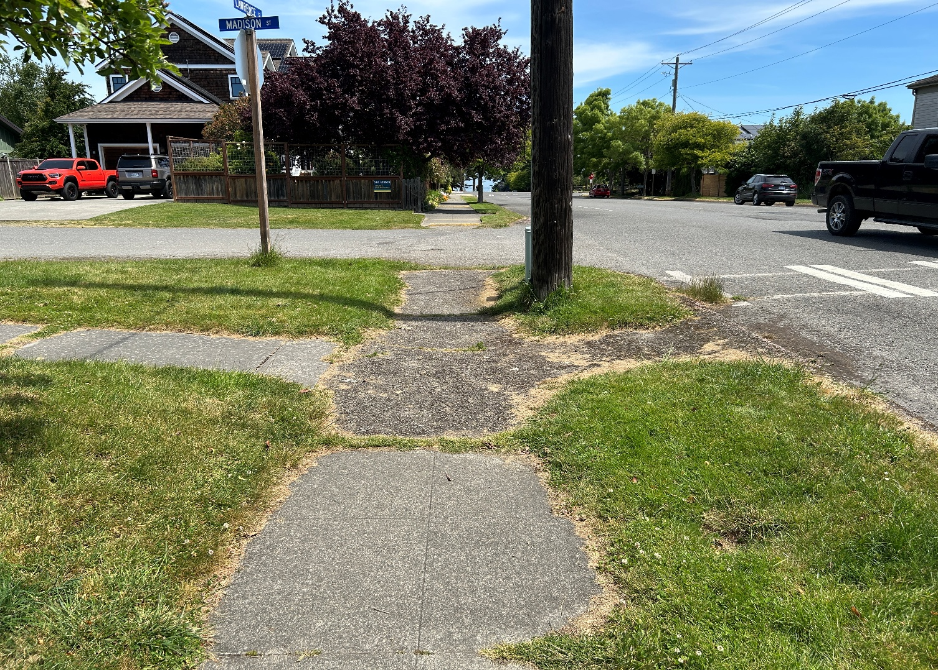

Poor pavement condition #1
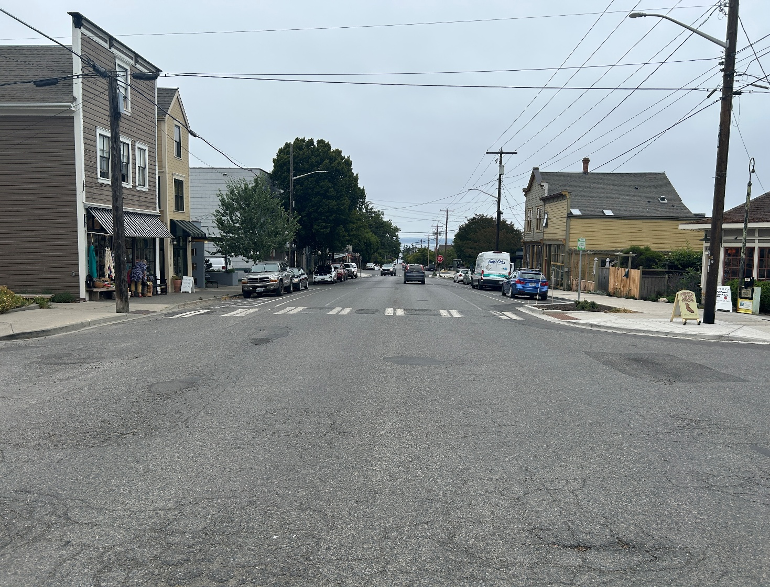

Poor pavement condition #2
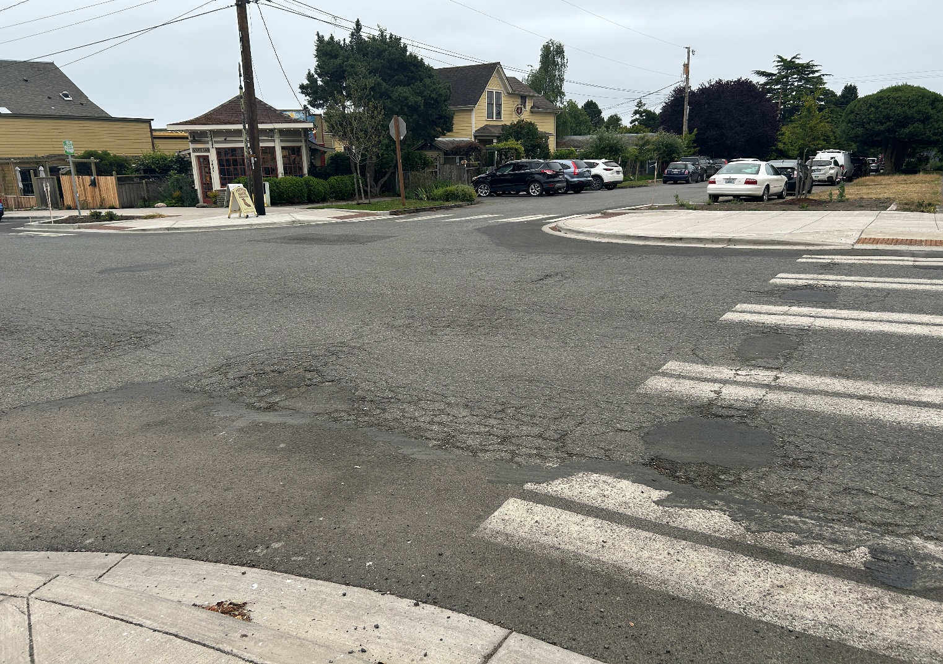

Poor pavement condition #3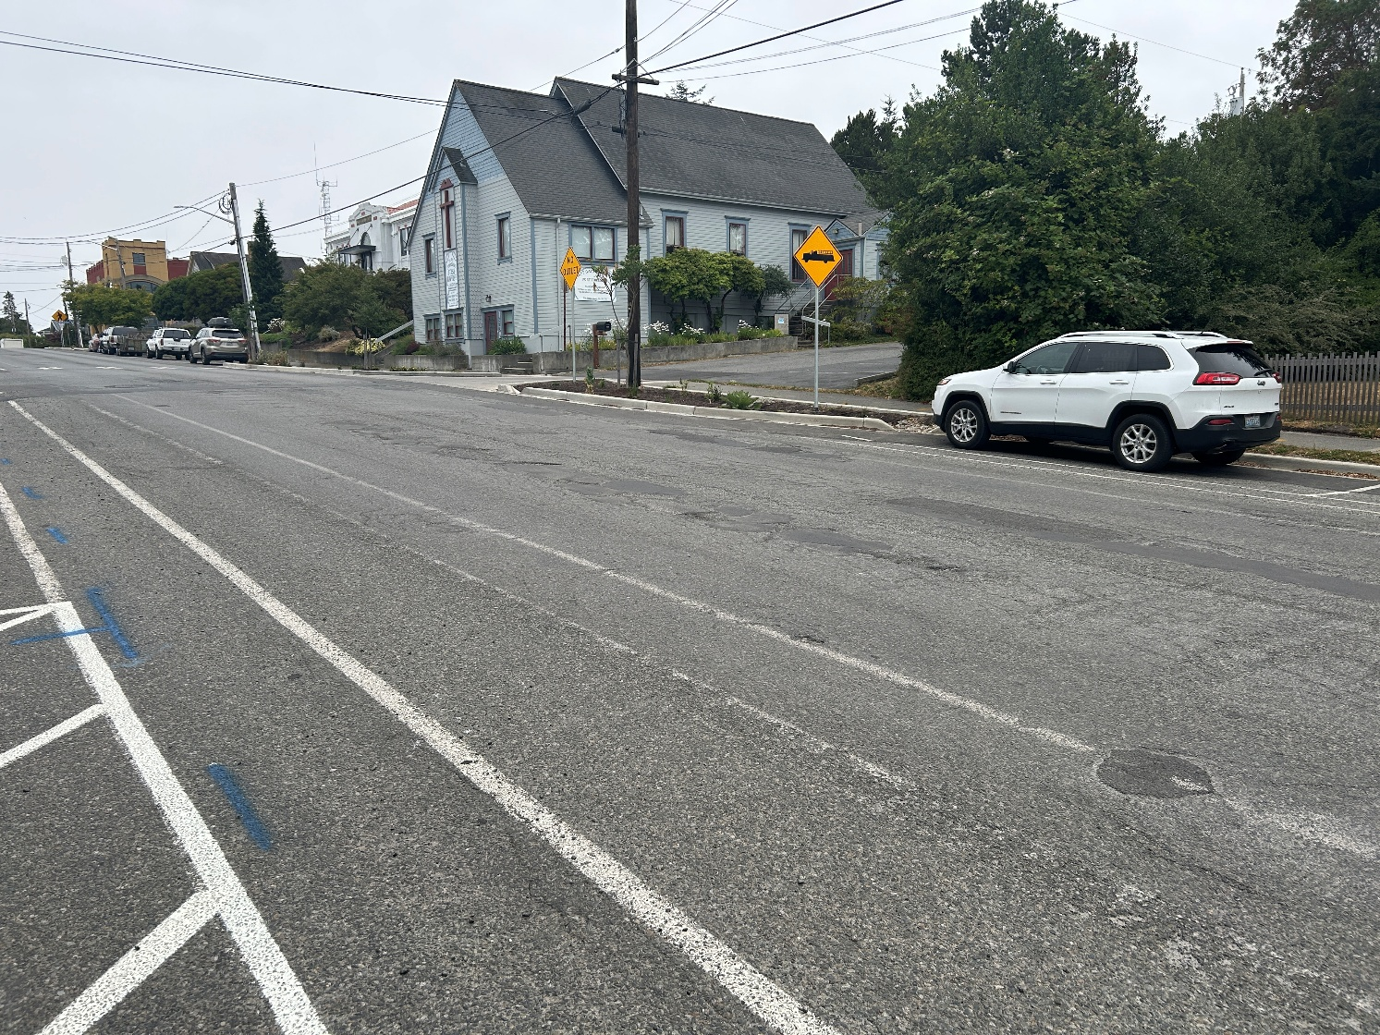

Poor pavement condition #4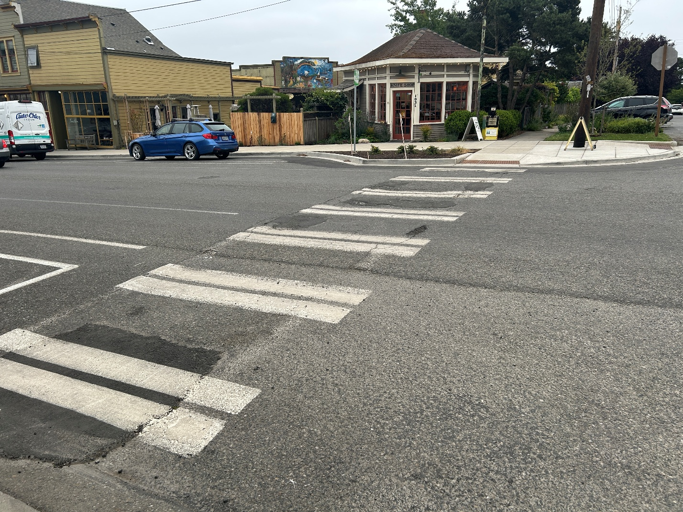

Poor pavement condition #5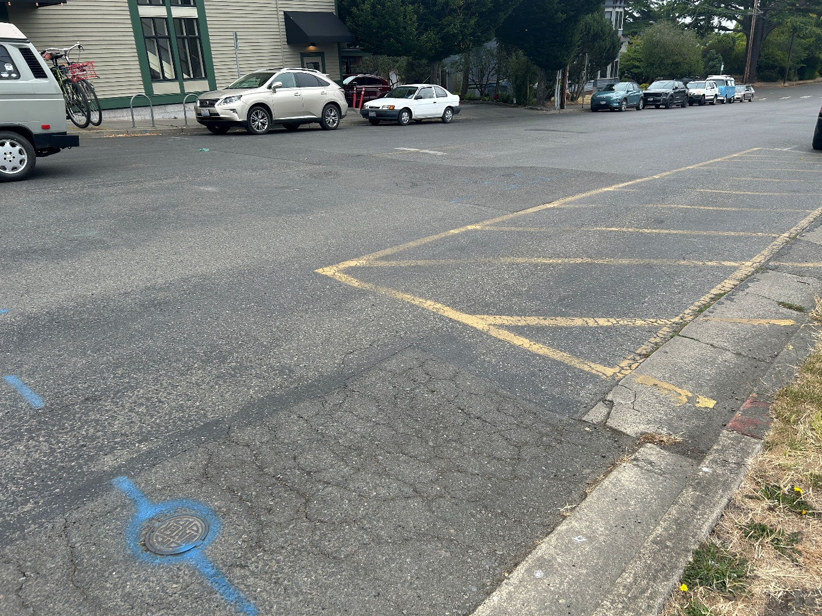

Poor pavement condition #6
